20/00994/CT3 – East Oxford Community Centre
Appendix 1 – Location Plan
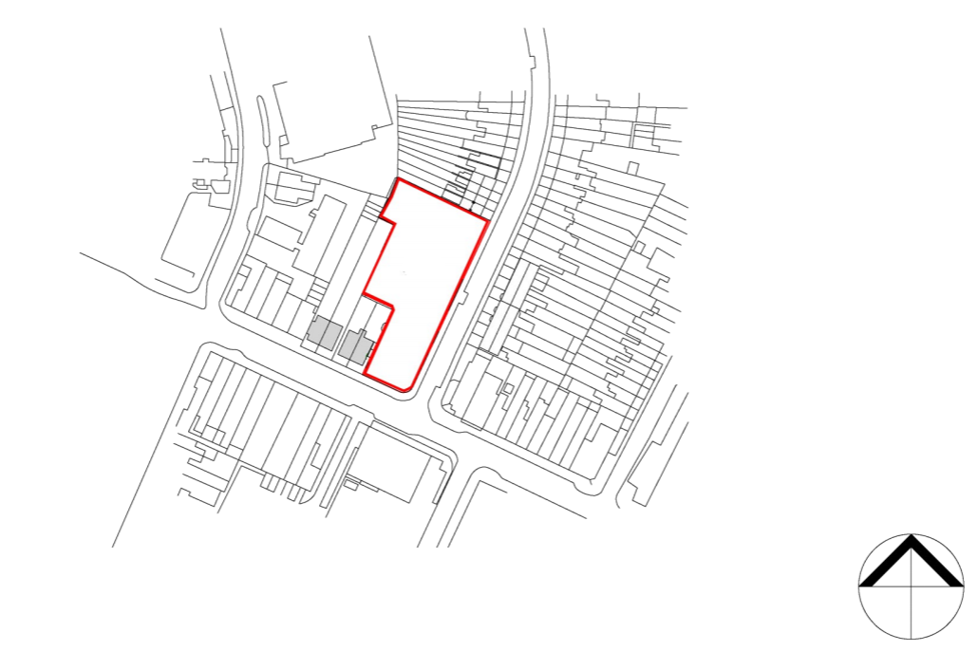
Princes Street
Cowley Road

